*The Afterburner* *(powered by chilly)*

|  |
| --- |
| **INITIAL INSTALLATION GUIDE**  **PLEASE READ THIS FIRST** |

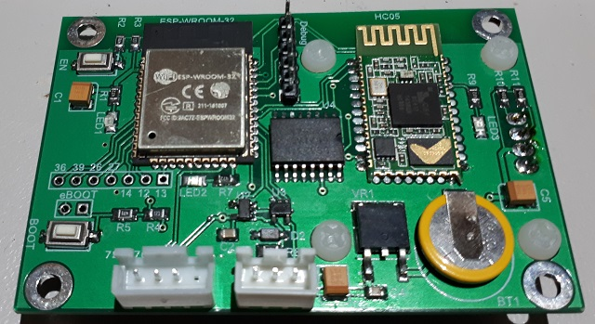

**A Bluetooth / Wi-Fi enabled controller for Chinese Diesel Heaters**

Congratulations on your acquisition of The Afterburner.  
This device allows you unprecedented remote controllability of your compatible Chinese diesel heater, and detailed examination of the run time conditions.

**DISCLAIMER**

The software of this design is released under the GPL V3 licence and is offered under the following disclaimer:  
  
*This program is free software: you can redistribute it and/or modify it under the terms of the GNU General Public License as published by the Free Software Foundation, either version 3 of the License, or (at your option) any later version.*

*This program is distributed in the hope that it will be useful, but WITHOUT ANY WARRANTY; without even the implied warranty of MERCHANTABILITY or FITNESS FOR A PARTICULAR PURPOSE. See the GNU General Public License for more details.*

*You should have received a copy of the GNU General Public License along with this program. If not, see <https://www.gnu.org/licenses/>.*

No responsibility will be taken for any damages caused by operating the Afterburner with your diesel heater system.

**COMPATIBILITY**

The Afterburner only works with compatible digitally controlled Chinese Diesel heaters.  
Not all heaters are digitally controlled.

The best discriminator is to inspect the control board housed within the heater unit.  
If it looks like either of the following, then your heater is compatible and will work with this controller.

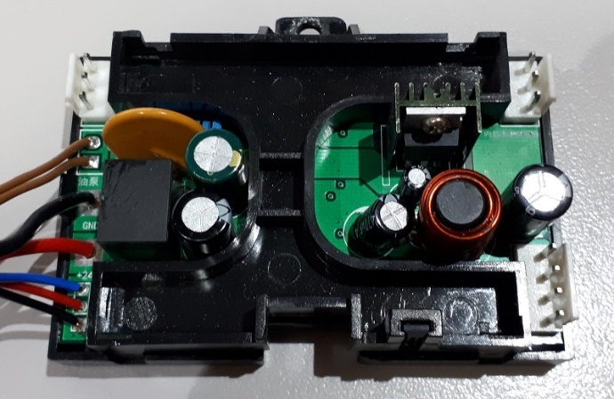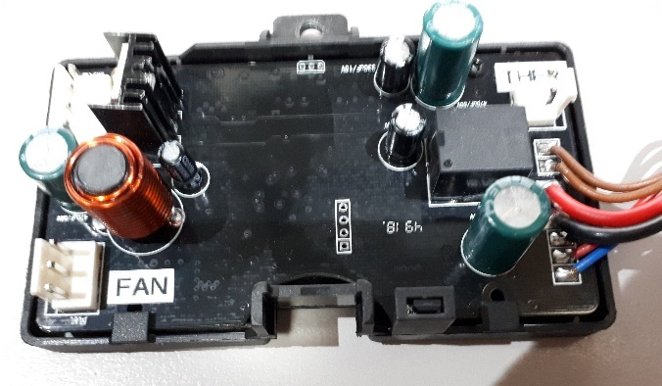

Note that both only have 3 wires to the head control unit, typically being red black and blue, which ultimately terminate in either a triangular or round waterproof connector:

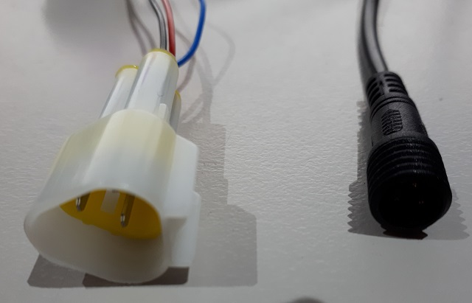

**BEFORE YOU START**

For seamless integration of this new controller with your existing system It is recommended to follow these installation instructions first.

|  |
| --- |
| **If this procedure is not closely followed, the Afterburner will obliterate the pre-existing tuning that may already be working well for you.** |

An important feature of the Afterburner is the ability to detect an OEM controller being present, and not attempt to change the heater’s tuning settings.

**The very first time you connect the Afterburner, do not simply replace the OEM controller, but do connect it in parallel with the existing controller.**

The appropriate connectors are replicated with the provided loom interface, allowing both controllers to be readily connected in parallel:

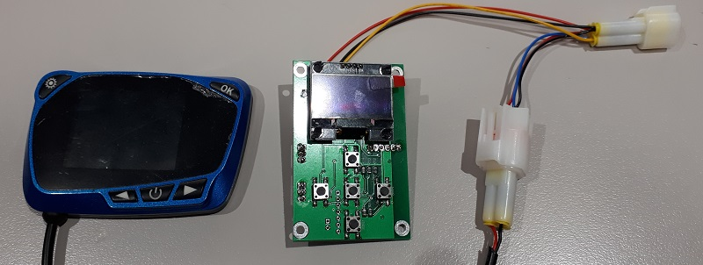

**Note that when both controllers are connected, only the OEM controller has proper control over the heater.**

The Afterburner will only be able to turn the heater on or off in this configuration, but more importantly it is able to observe the tuning parameters of the heater which are leveraged during this procedure.

How you initially proceed is determined by the type of controller you presently own.

# Initial Connection and Start-up Procedure

|  |
| --- |
| **When updating from a knob controller this connection procedure must be followed exactly.**  **The heater’s embedded tuning parameters will be obliterated and unrecoverable if the Afterburner is connected without the rotary knob controller prior to extracting the required information.**  **Do not replace the controller when power is applied to the heater.**  **You have been warned!** |

1. Ensure the diesel heater has all power removed, eg: remove its main supply fuse.
2. Unplug the existing OEM controller from the heater’s loom.
3. Plug the OEM controller into the provided socket on the Afterburner’s loom.
4. Plug the new Afterburner loom interface into the heater’s loom.

The Afterburner is now connected in parallel with the OEM controller.

1. Restore power to the diesel heater, both the OEM controller and Afterburner should now power up.

The extraction of the pre-existing settings now depends upon the style of OEM controller fitted.

* **Knob style rotary controller**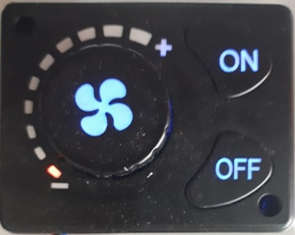  
  Extracting the tuning parameters from a knob style controller system is very tedious, but possible, please continue onto the next page.  
  **If you have a rotary knob controller, you must follow the detailed procedure.**
* **Other (digital readout) controllers – typically LCD variants**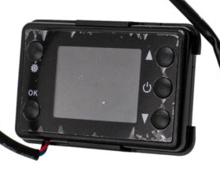 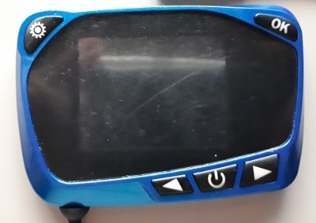 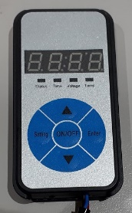  
  Extraction of the tuning parameters from a digital/LCD controller system is very quick and easy to achieve**, please skip forward to page 12.**

# **Rotary knob style controller parameter extraction procedure**

When a rotary knob controller is the user interface, the fuel mixture settings are only stored within the heater unit and are not directly visible via the communications protocol.

Whilst the rotary knob controller does transmit tuning parameters in its control packets, they are ignored by the heater. This behaviour is determined by the very first data value sent to the heater.  
**The rotary knob controller’s settings, whilst visible in the data protocol, are just arbitrary values.**

However, as the Afterburner can observe the actual **running** condition of the heater, the embedded tuning parameters can be determined by running the heater and observing the values fed back as the heater operates at the extremes of “Fixed Hz” mode.

The heater’s parameters whilst running are available in the Detailed Control menu.  
Use the LEFT keypad button to navigate to the Detailed Control display from the initial default Basic Control menu.

The following diagram illustrates the menu tree structure:

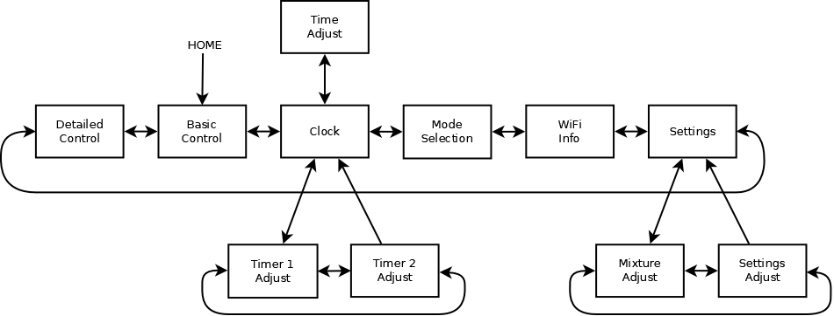

#### Fan RPM sensor

A pair of magnets are installed in the rim of the blower fan.   
These magnets are sensed by a Hall Effect sensor inside the heater, measuring fan RPM.

Normally these are installed with an opposing magnetic polarity.  
If they are incorrectly installed with the same polarity the Hall effect sensor’s output will read twice the true RPM.

To allow for possible mistakes during manufacture, a tuning parameter is provided which allows the heater to set the division ratio of the Hall Effect sensor, either ÷1 or ÷2.   
These are known as SN-1 and SN-2 respectively in the digital/LCD controller menus.

When using a rotary knob controller, we cannot directly determine what this parameter is set to, but we can record the fan voltage vs RPM to later determine the correct value for SN-x.

The fan voltage is shown on the Afterburner’s Detailed Control menu if the CENTRE keypad button is briefly pressed whilst running.

#### Establish normal “Running” State

Start the heater and **wait at least 5 minutes** for the normal running state to be established.

|  |
| --- |
| Actual control of the heater is not possible until “Running” state is established |

The Detailed Control menu will indicate when the running state is achieved:

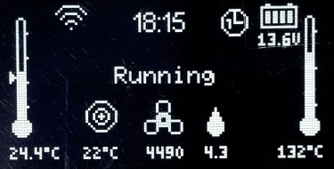

|  |
| --- |
| **DO NOT PROCEED UNLESS THE RUNNING STATE HAS BEEN REACHED** |

#### Fixed Hz mode

Confirm the controller is set to “Fixed Hz” mode.   
This indicated on the Detailed Control menu by a Hz value being shown beneath the target icon:

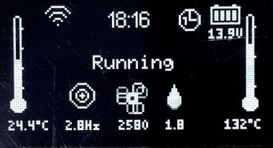

If the value shows a temperature (XX°C) value, you need to change the knob controller to use “Fixed Hz” mode:

* Hold the ON switch of the rotary knob controller for about 10 seconds.
* The rotary knob should change colour from red to blue.

The target value should now show Y.YHz, instead of XX°C.

#### Maximum fuel mixture setting

Rotate the knob clockwise on the rotary controller until all indicator LEDs illuminate about the knob.

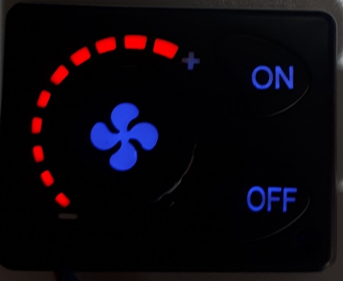  
This demands the maximum fuel pump rate, the value of which is immediately indicated as the Afterburner’s target demand.

|  |
| --- |
| **The heater will not instantly react to the full power demand.  It takes around a minute for the new demand to stabilise.** |

**Wait at least one minute**

The actual fuel pump rate shown beneath the animated fuel drop icon should now match the demanded pump rate beneath the target icon.  
In the table provided on the next page,  **record the maximum fuel pump rate** from the Afterburner’s target value.

The fan will now also be running about the heater’s maximum programmed setting.  
Observe the indicated fan RPM beneath the animated fan icon.   
It is normal for this value to fluctuate, but a typical median fan speed should soon become evident.  
*Note: the heater only reports to a 10 RPM resolution.*  
In the table provided on the next page, **record the maximum RPM** using the established median valuefrom the Afterburner’s display.

In the table provided on the next page, **record the corresponding fan motor voltage** from the Afterburner’s menu.  
*This value is normally hidden, briefly press the* CENTRE *key to reveal this voltage in place of the usual RPM value beneath the animated fan icon.*

#### Minimum fuel mixture setting

The minimum settings can now be established by rotating the knob anti-clockwise until only the first LED illuminates.

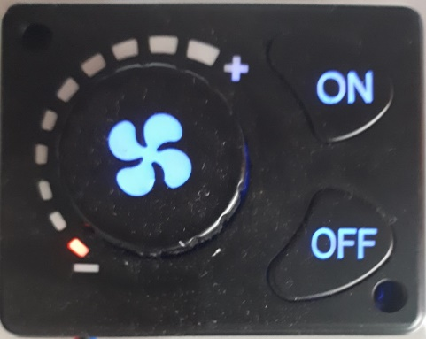

Once again, **wait at least a minute** letting the heater establish the minimum power settings.

After the heater has stabilised, the actual pump rate should again match the demanded pump rate.  
**Record the minimum fuel pump rate** from the Afterburner’s target value.

Observe the fan RPM beneath the spinning fan icon.   
**Record the minimum RPM** using the observed median value from the Afterburner’s display.

**Record the minimum fan motor voltage** from the Afterburner’s display.

#### Fuel mixture settings record

|  |  |  |  |
| --- | --- | --- | --- |
|  | Pump Speed | Fan RPM | Fan Voltage |
| Minimum |  |  |  |
| Maximum |  |  |  |

### **Transferring settings into the Afterburner**

We have now established the fuel mixture settings that are stored within the heater.  
These settings now need to be configured into the Afterburner controller.

Whilst the OEM controller is connected, certain Afterburner menus are deliberately disabled.  
The Heater Settings menu is one of those.

Unplug the OEM controller from the heater loom.  
The Afterburner now has full control over the heater, all menus are fully enabled.

Using the LEFT keypad button, navigate to the Heater Settings menu from the Detailed Control menu:

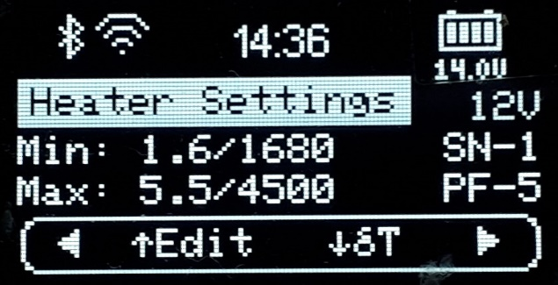

To enter the settings, press the UP keypad button.

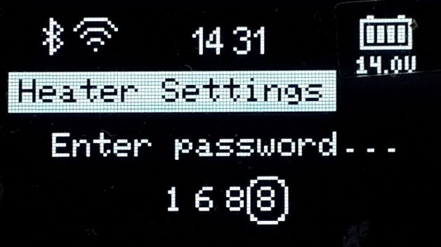

Enter the password “1688”:

* Alter the selected digit by using the UP/DOWN buttons.
* Select the next digit using the LEFT/RIGHT buttons.
* Once “1688” is displayed, press the CENTRE button.

The menu system is now shifted into the Heater Settings menu loop.  
Editing of the heater parameters is now enabled.

###### **Fuel Settings**

Referring to the recorded settings:

Press UP.  
Adjust the minimum fuel pump rate.  
Increase/decrease the value by using RIGHT/LEFT respectively to match the value recorded earlier.

Press UP.   
Adjust the maximum fuel pump setting using RIGHT/LEFT.

Press UP.   
Adjust the minimum fan RPM using RIGHT/LEFT.

Press UP.   
Adjust the maximum fan RPM using RIGHT/LEFT.

Once all values are set to those recorded earlier, press CENTRE then press UP to confirm the save.  
The settings are now stored into non-volatile memory within the Afterburner.

The selection box will return to the bottom menu navigation line.  
We remain in the Heater Settings menu loop.

##### **System Voltage & Fan Divisor**

Two remaining parameters are required to be entered.  
System voltage, and fan division ratio (SN-x).

These are accessible in the other tuning menu, press RIGHT or LEFT to access this menu.  
The parameters can then be selected using the UP button.

* The glow plug power is usually best left at PF-5.
* The fan division ratio is usually SN-1, and we will trial that for the initial run.   
  We will confirm the correct setting by comparing the fan voltage during run versus the recorded values.
* The system voltage should be set as per your unit’s battery system, typically 12V in most instances.

Once these parameters are correctly defined, press CENTRE then press UP to confirm the save.  
The settings are now stored in non-volatile memory within the Afterburner.

The selection box will return to the menu navigation line.  
Leave the Heater Settings menu loop by pressing the CENTRE keypad button.

#### **First test run**

Now in the Main Menu loop, return to the Detailed Control menu by pressing RIGHT.

Start the heater by holding the CENTRE key for about 1 second.  
The display should indicate “Starting…” then “Heating glow plug”, instead of “Stopped/Ready”.

After a few seconds, allowing the fan to build speed, a quick check of the fan voltage can be made.  
Briefly press the CENTRE keypad button, the voltage will be shown beneath the spinning fan icon.

During the initial start phase, the fan RPM starts near the minimum RPM setting.   
If the fan division ratio is correct, the fan voltage should also be close to the value previously recorded for minimum fan speed.   
If the voltage is grossly different, roughly half the minimum recorded value, it is likely the trial SN-1 parameter should be changed to SN-2. *The heater is observing the required RPM, but this only requires half the voltage. i.e. the sensed speed needs to be halved.*

If the heater continues to run with the wrong SN-x value, it is possible an E-06 fan speed fault will be thrown, especially when SN-2 is incorrectly set the heater cannot apply enough voltage to reach the apparent speed for maximum fan mode.

Assuming the heater continues to run, congratulations you have successfully installed your Afterburner controller, retaining the previous fuel mixture settings.

## **Digital readout style / LCD controller settings extraction procedure**

Digital (LCD) controllers have full control over the fuel mixture settings and operation parameters.

As such the tuning settings delivered to the heater via the communications protocol are the true running parameters of the heater.

As the Afterburner can intrinsically read these parameters, the process of inheriting them into the Afterburner’s non-volatile memory is incredibly easy.   
The process is completed within a few keystrokes, unlike the tedious process required to infer the heater’s settings when using a rotary knob controller.

### **LCD parameter inheritance procedure**

In the Afterburner’s menu system, navigate to the Heater Settings menu.   
*From the default* Basic Control *menu, press the LEFT key twice (second menu to the left).*



When an LCD controller is attached, the values shown on the Heater Settings menu are the actual settings being advertised by the LCD controller.  
If you try to edit these by pressing the CENTRE key, a warning will come up that another controller is present, i.e. the action is prohibited.

However, if you press UP the ability to inherit the LCD’s settings begins:

1. Initially Press UP to start the inheritance process
2. Press RIGHT to confirm you wish to the inherit the LCD controller’s settings
3. Enter the password – “1688”:
   * UP/DOWN keys adjust the digit value
   * LEFT/RIGHT keys select the next digit
   * CENTRE key confirms the password entry

An invalid password or not pressing RIGHT at step 2 will always abort the inheritance process.

If the password is entered correctly, the settings shown are saved into non-volatile memory.

Congratulations you have successfully installed your Afterburner controller, retaining the previous fuel mixture settings. In the future when the Afterburner is used without the LCD attached, the heater then will run with identical tuning parameters as prior.